Reservation Form

Conference Name | INTERNATIONAL NUCLEAR EXPO 2026 (INEX 2026)

▶ Please complete the form and send it to rsvn@centumpremier.net or Fax 82-51-747-7923

< Personal Information >
Last Name |  | First Name
CHECK IN | Yy / mm / dd | CHECK OUT | Yy / mm / dd
Mobile |  | E-MAIL

< Credit card details for guarantee >
CREDIT CARD | □ VISA □ Master □ AMEX □ JCB □ Others ( )
CARD NUMBER |  | EXPIRATION DATE (MM/YY) | /
HOLDER’S NAME |  |  | Signature
I, the person above, guarantee for the reservation made, and agree to use this credit card only for cancellation fees or no-show costs. |  |  | Signature
▶ According to the regulation, the fee will be automatically paid by registered card in case of No-show or Cancelling on the check-in day.

< Room Preference >
ROOM TYPE | Size | SPECIAL RATE  (KRW) | NUMBER  OF ROOMS | NUMBER  OF Guest | REMARK
Superior Single | 19.3~20.1㎡ | 77,000 |  |  | 1 Single Bed
Superior Double | 20.3~21.8㎡ | 88,000 |  |  | 1 Double Bed
Superior Twin | 20.3~21.8㎡ | 99,000 |  |  | 2 Single Beds
Deluxe Double | 22.1~23.3㎡ | 110,000 |  |  | 1 Double Bed
Deluxe Twin | 27.0~27.1㎡ | 121,000 |  |  | 2 Single Beds
Family Twin | 27.1㎡ | 132,000 |  |  | 1 Double + 1 Single
Breakfast : KRW 19,800 / per 1 person |  |  | YES □ / NO □

▶ The rate above is only for INEX 2026, VAT included.
▶ The rate above is only be used date between 20th APR ~ 25th APR only.
▶ Check-in : 15:00 pm, Check-out 11:00 am. (There will be extra charge for late check-out 11,000 won per hour).
▶ Special rate could be unavailable due to room occupancy and sales volume.
▶ Use the room on Saturday, an additional KRW 22,000 will be charged.
▶ The website reservation promotion code is " INEX4 ".
( Reservation -> Promotion Code -> Corporate code -> INEX4 )
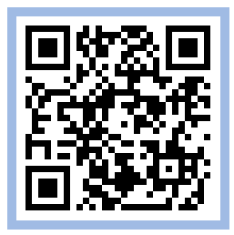
<Cancellation & No-Show regulation>
▶ 100% refund before 4 days to Check-in,
▶ 100% cancellation fee of the 1night room will be charged after 18:00 3 days prior to check-in.

HOTEL | Reservation INFO
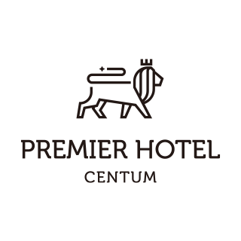 | TEL : 051-755-9000 / FAX : 051-747-7923  E-MAIL : rsvn@centumpremier.net  ADDRESS : (48060) 17Centum 1-ro, haeundae-gu, Busan  HomePage : https://www.centumpremier.net

